**Actions performed by the Tool**

**(Customer with existing credit records - No Duplicate Amount)**

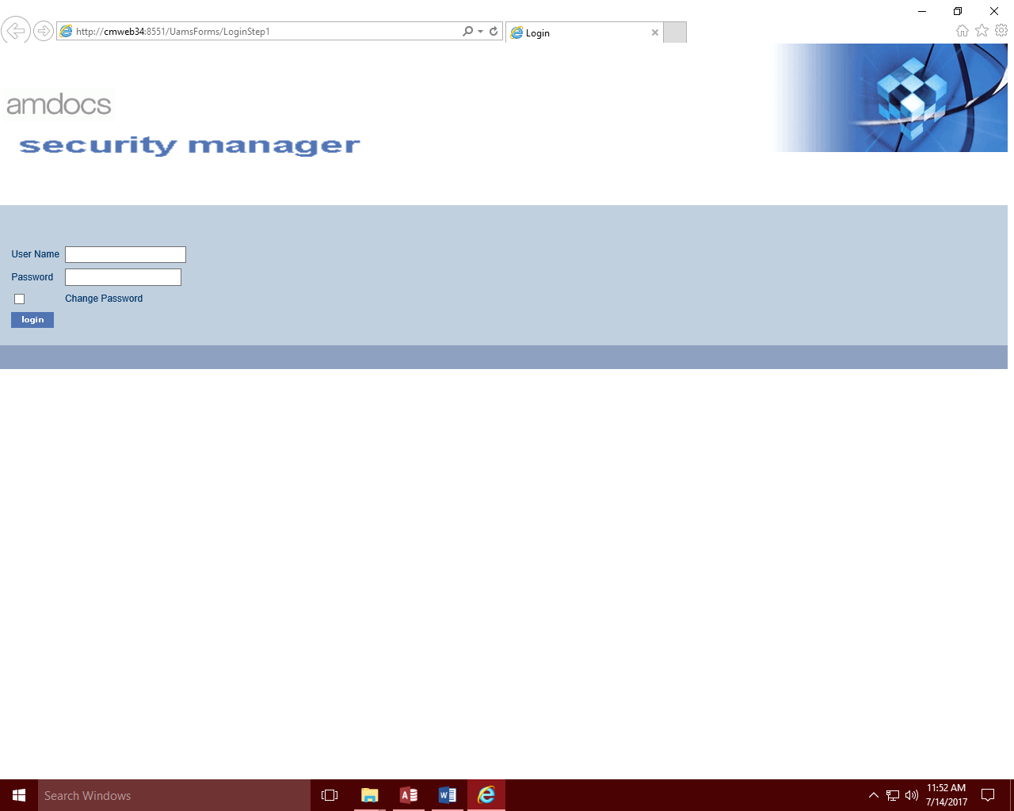

1. **Loading the Login Screen**

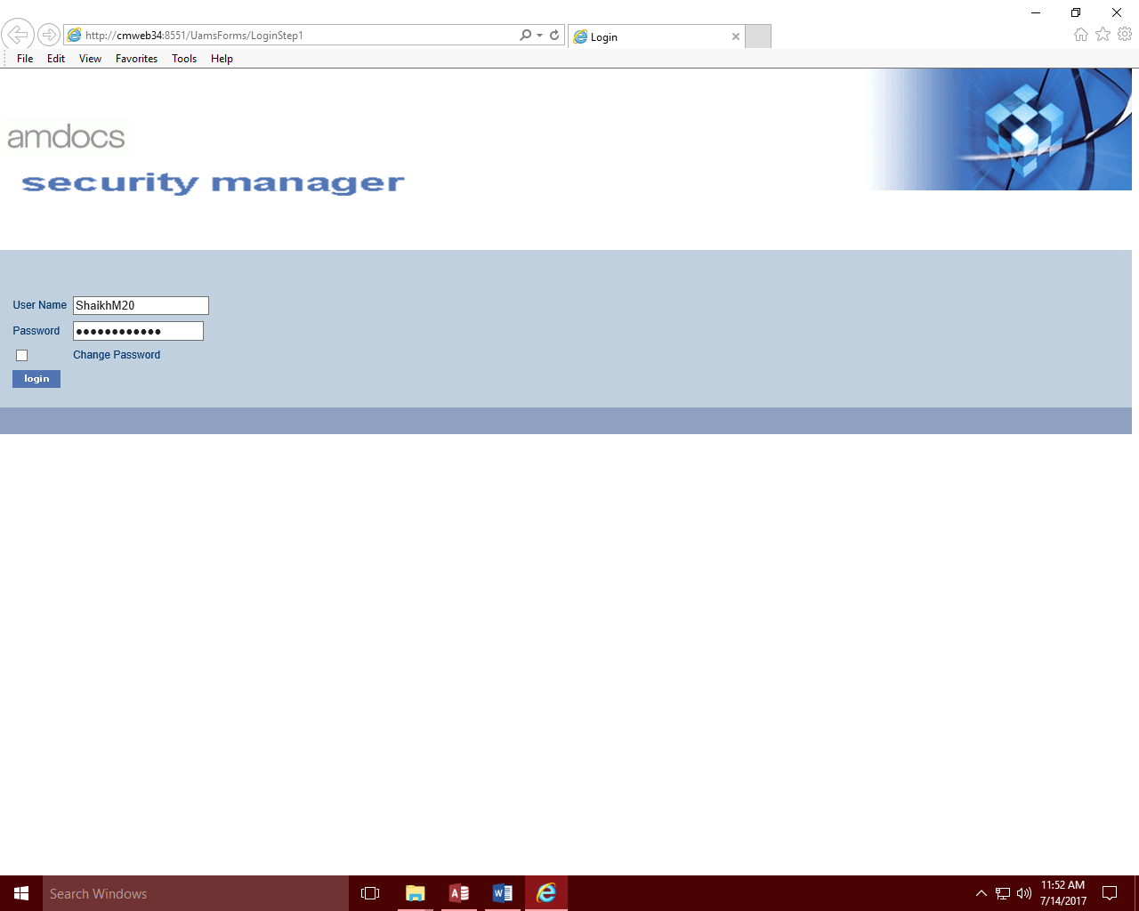

1. **Authentication: Login Information retrieved from the Tool and being populated**

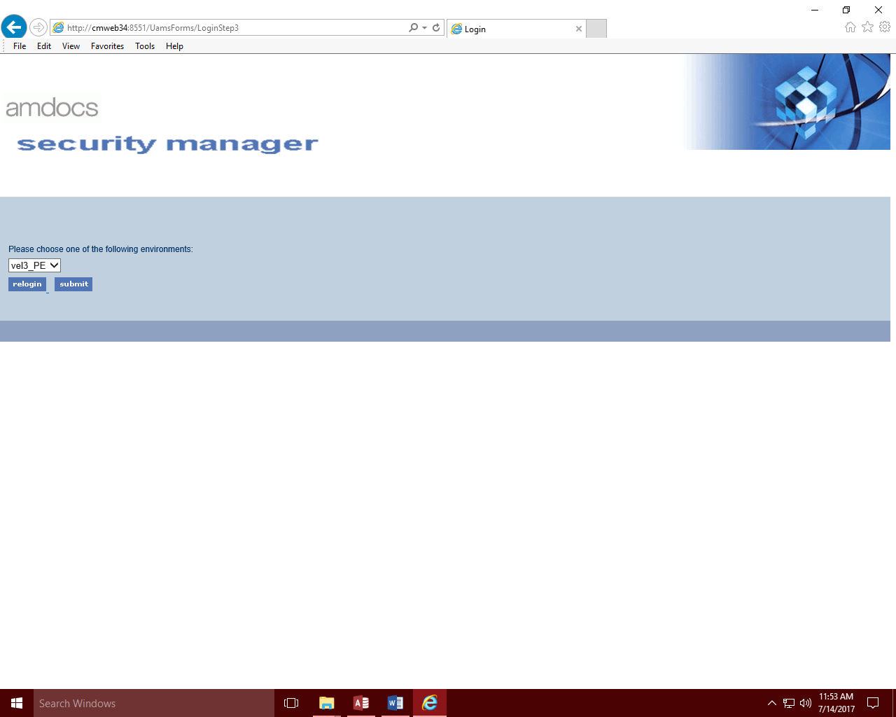

1. **Loading the environment selection screen on successful authentication**

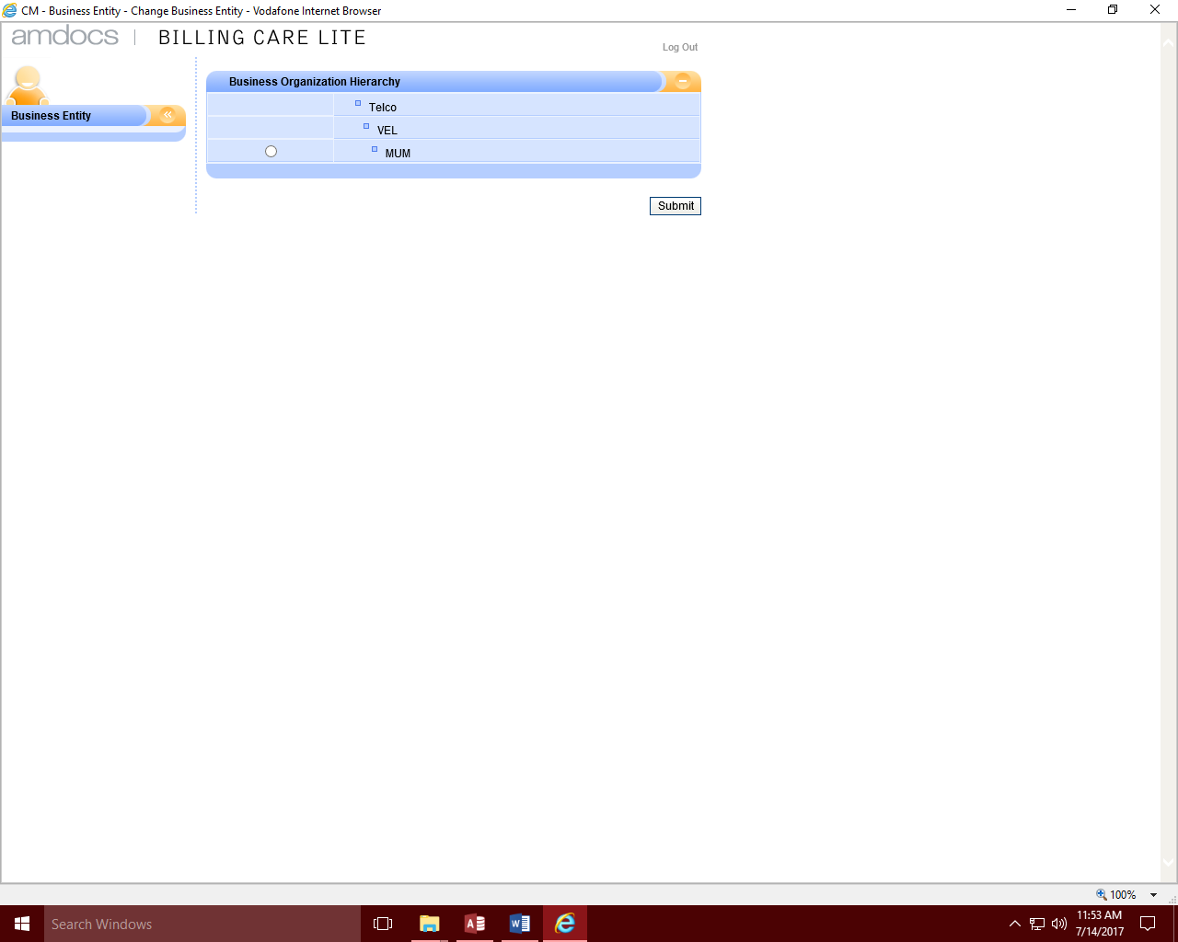

1. **Loading the Business Organisation hierarchy**

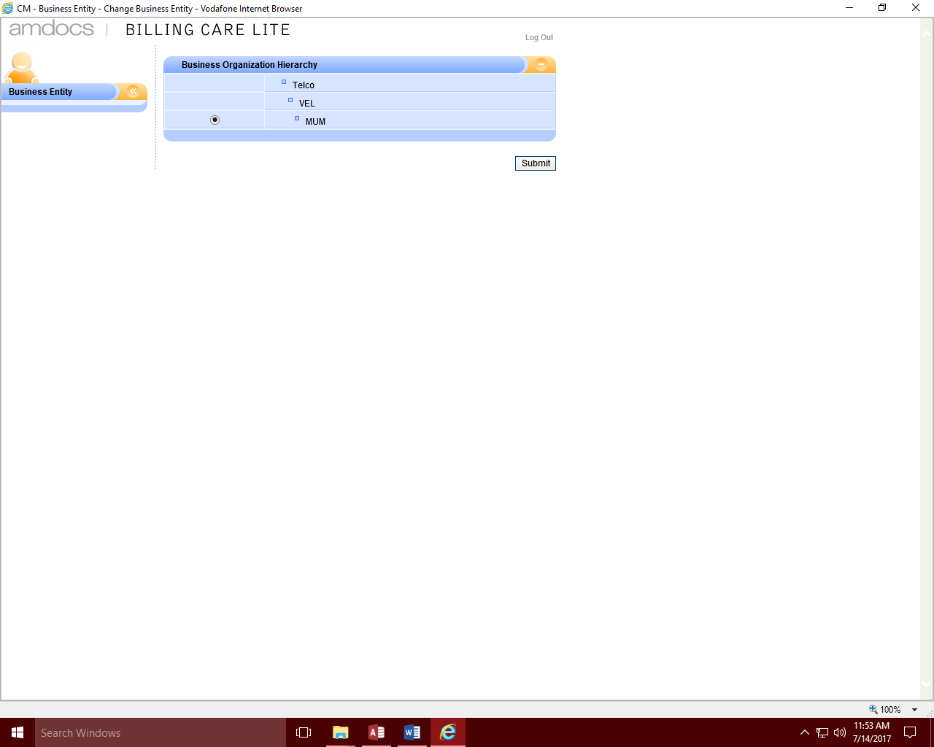

1. **Selecting the appropriate Business Organisation hierarchy**

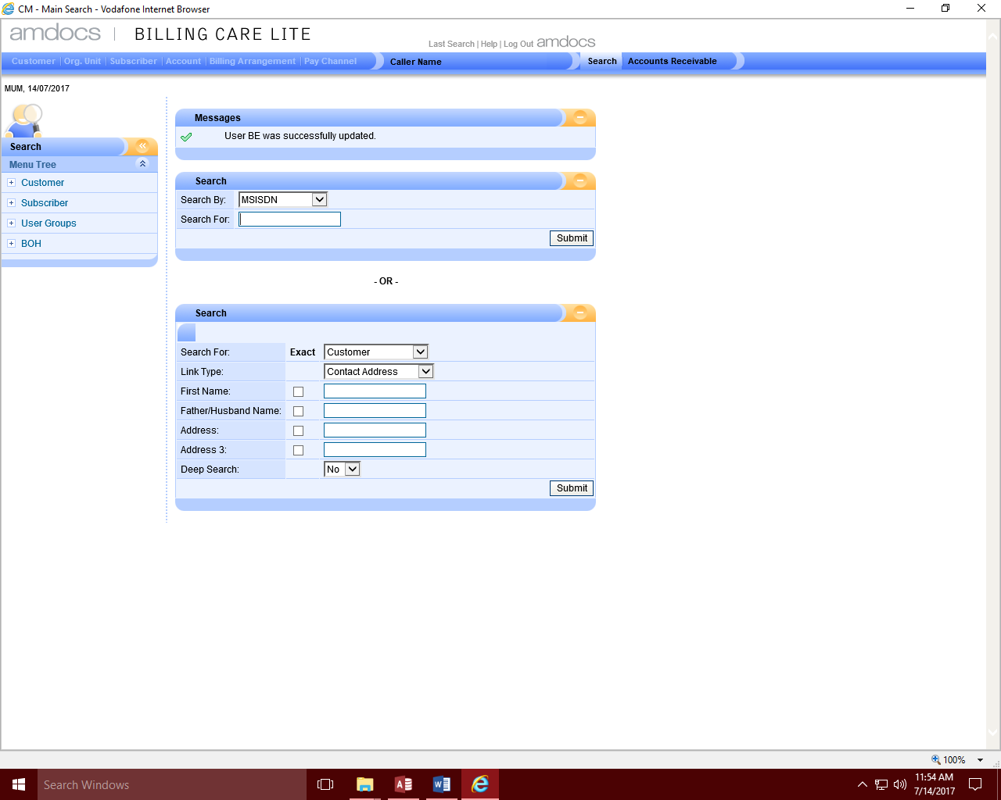

1. **Navigating to the Search screen**

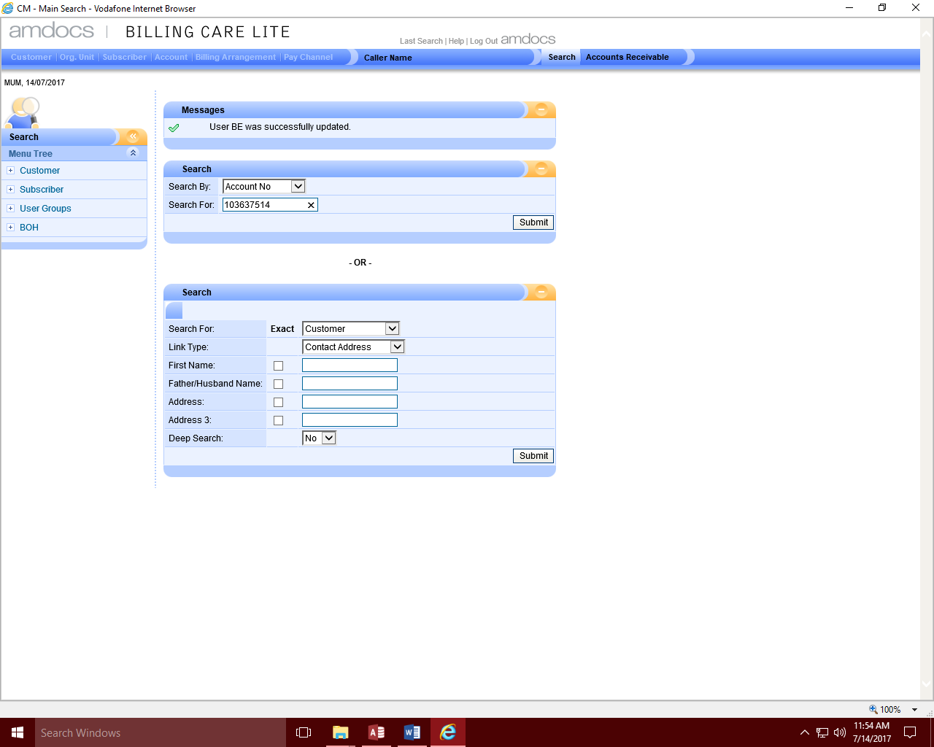

1. **Selecting the Account number search criteria and populating the account number**

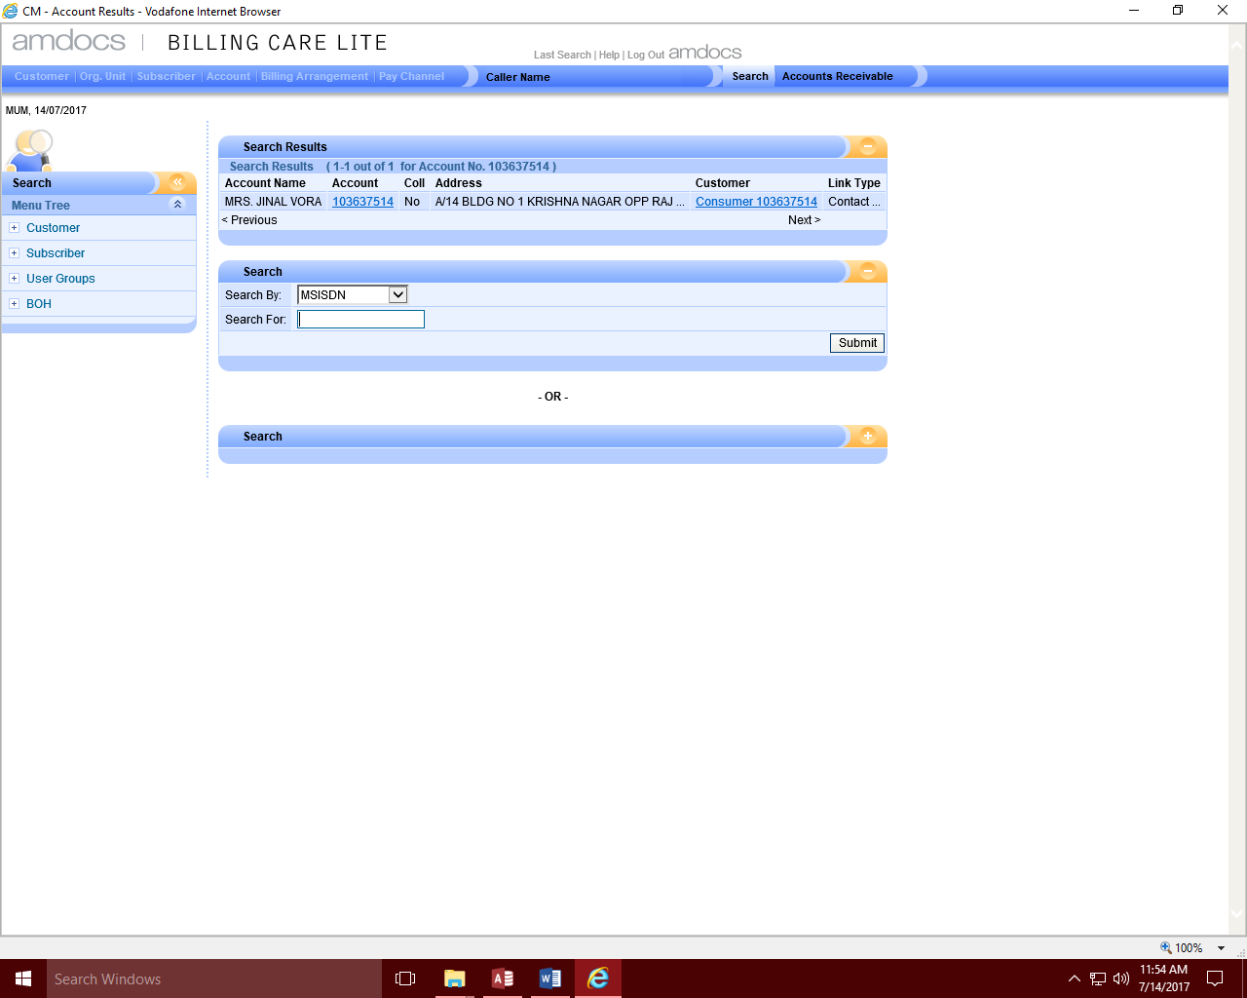

1. **Account details getting displayed after submitting the account number**

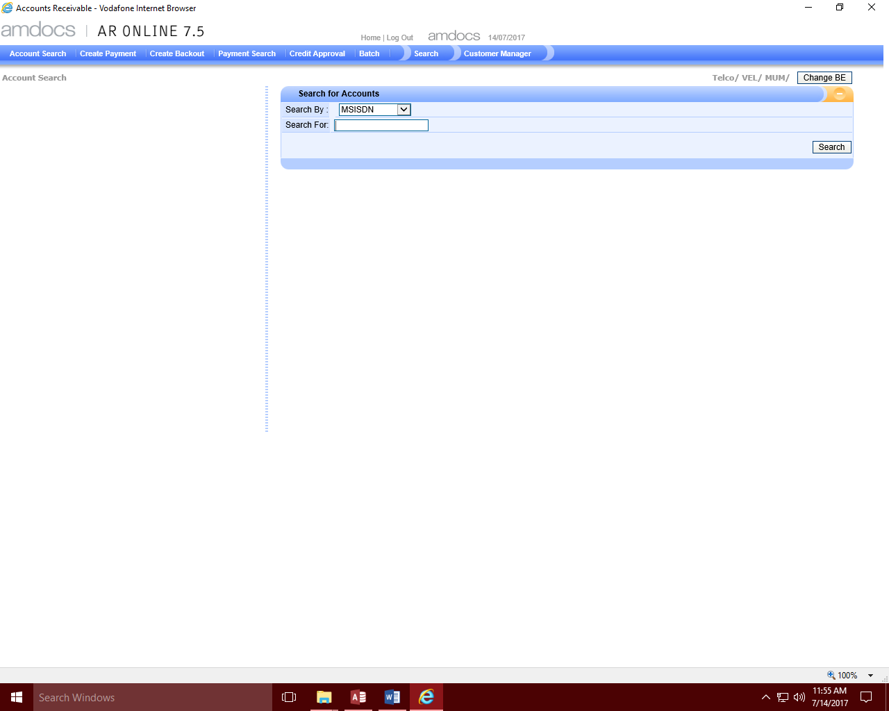

1. **Navigating to Accounts search screen after clicking Accounts Receivable option**

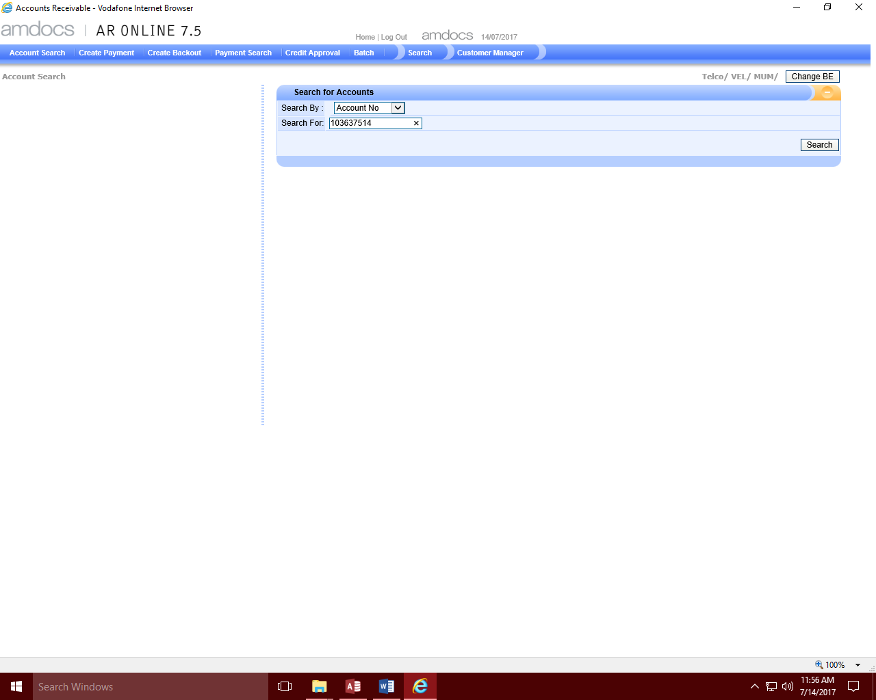

1. **Selecting the Account number search criteria and populating the account number**

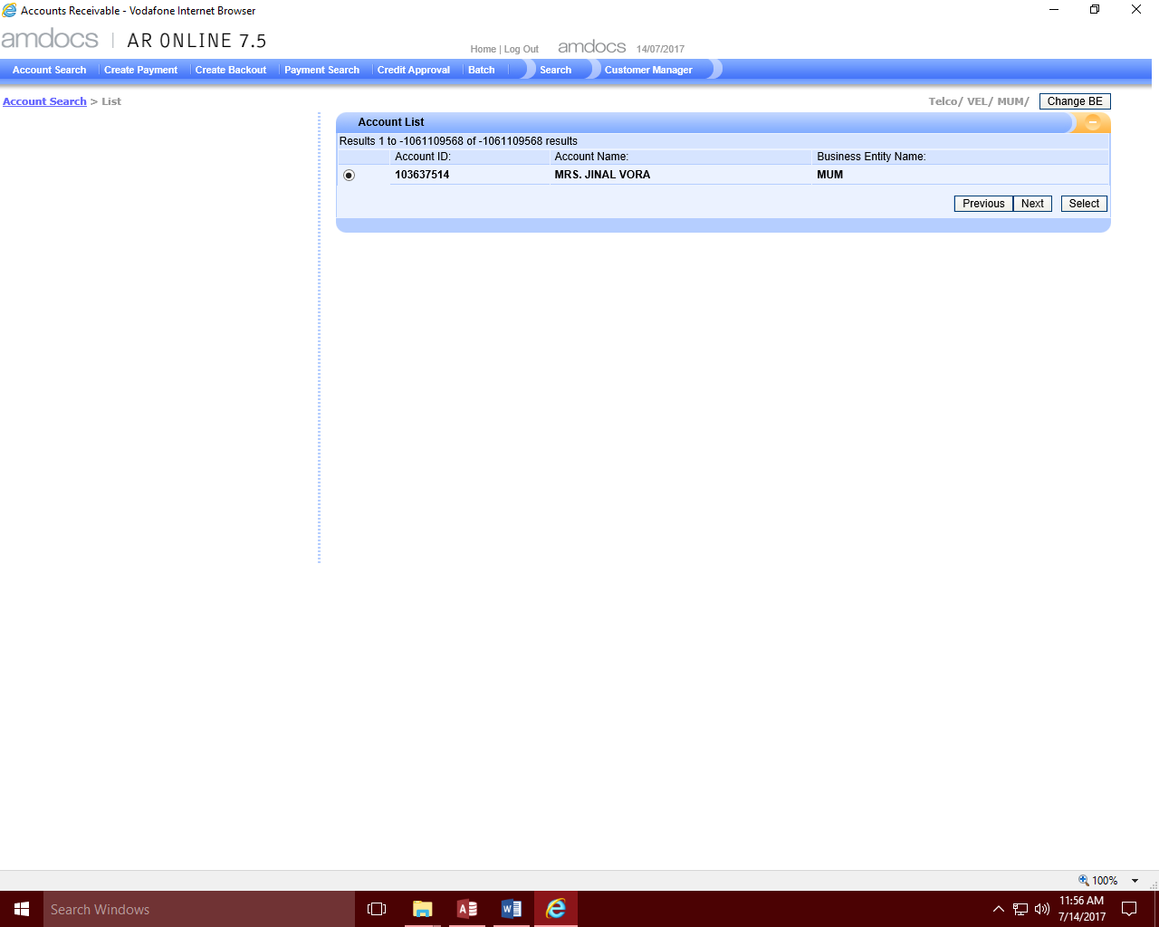

1. **Listing the Accounts on clicking the search button**

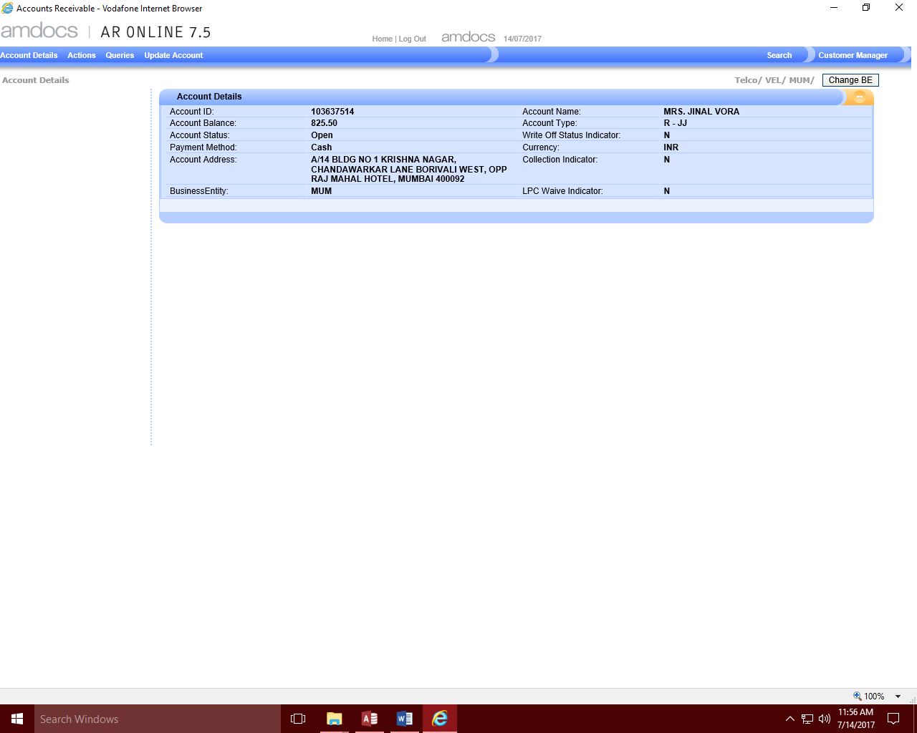

1. **Displaying the accounts detail information on clicking the select button**

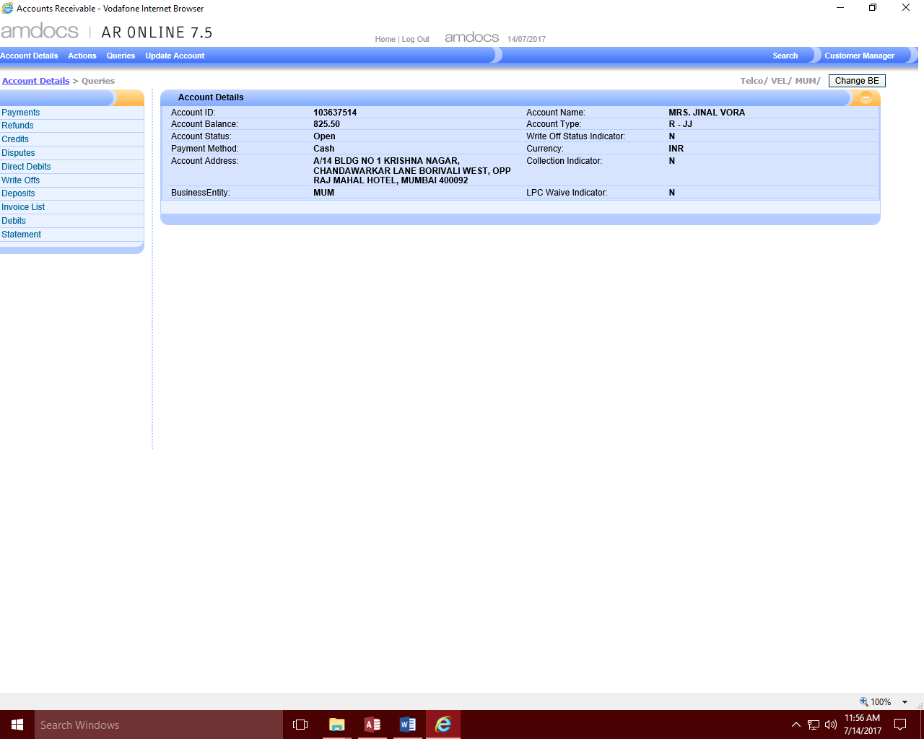

1. **Display on clicking the Queries Option**

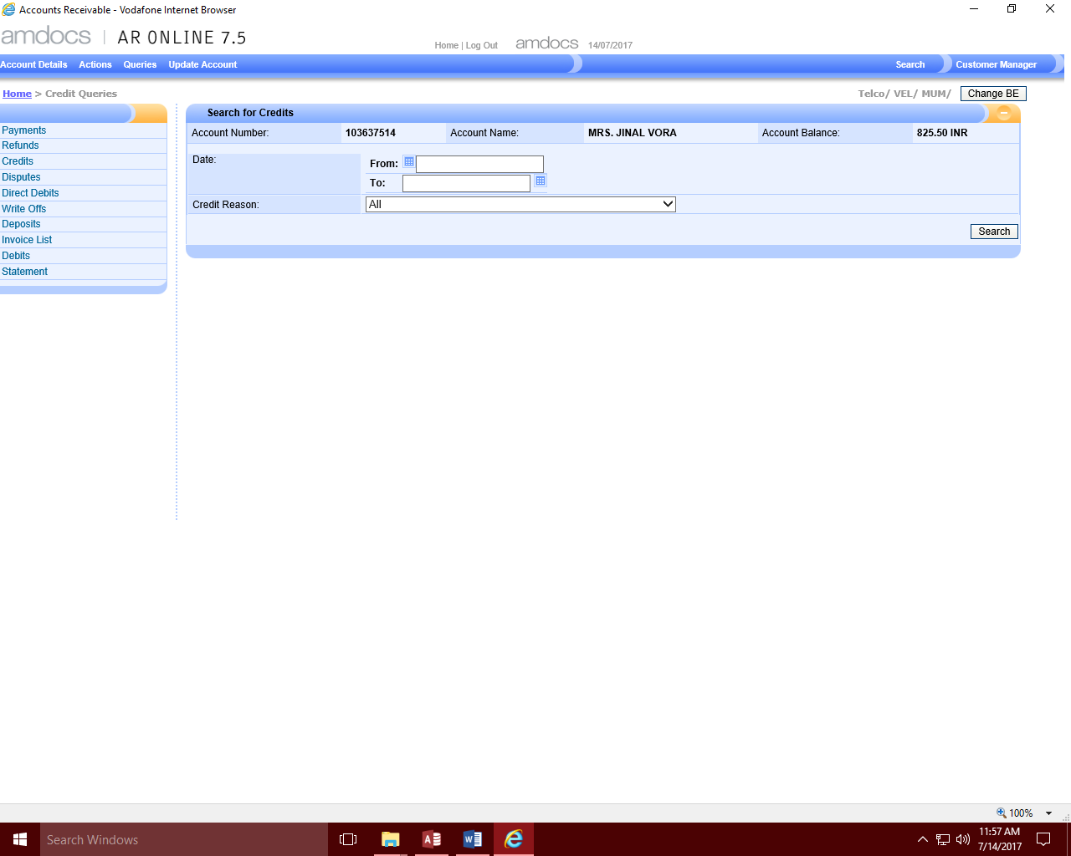

1. **Navigating to the Search Credits screen on clicking Credits**

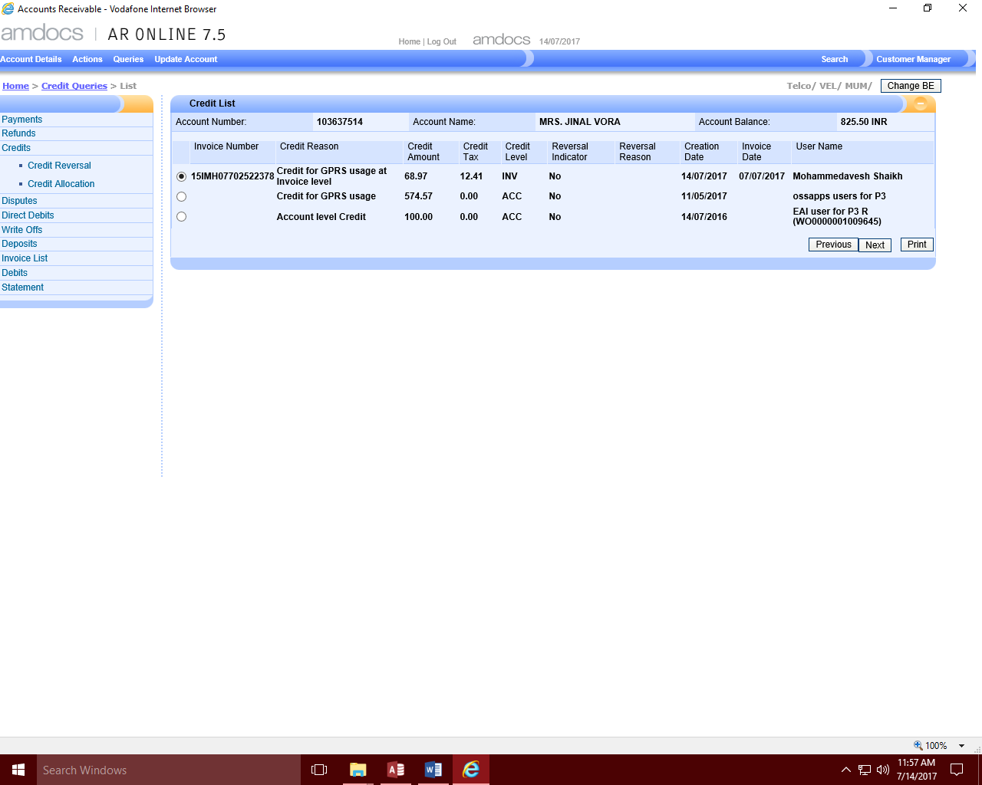

1. **Displaying Search Results on clicking Credit Search**

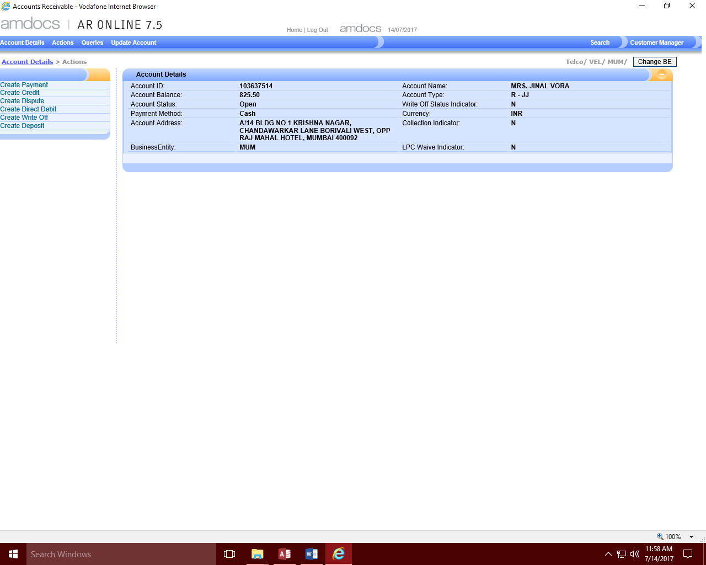

1. **On clicking Actions (No duplicate amount found)**

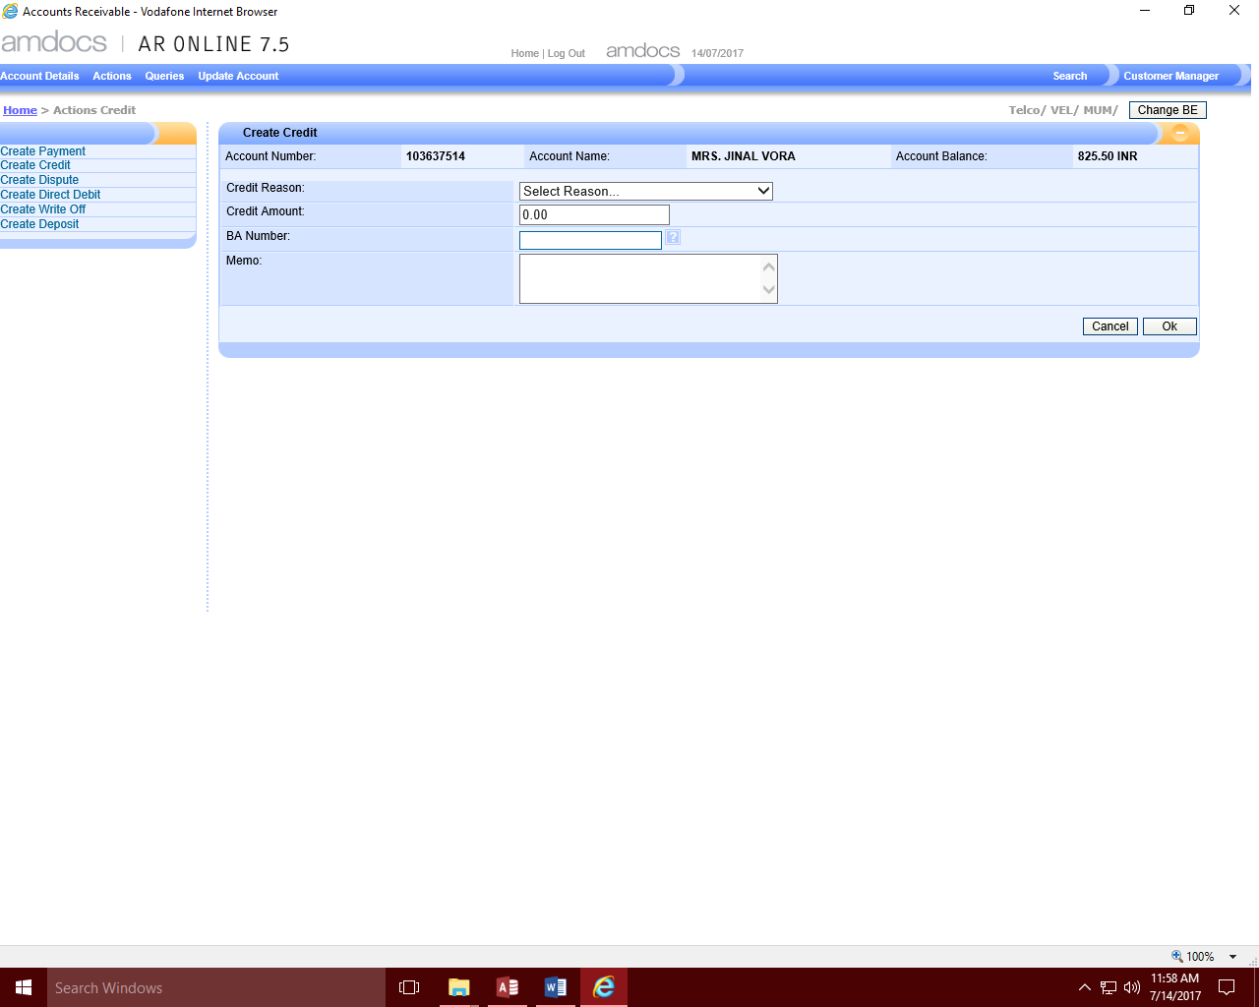

1. **Navigating to the Create Credit screen on clicking Create Credit**

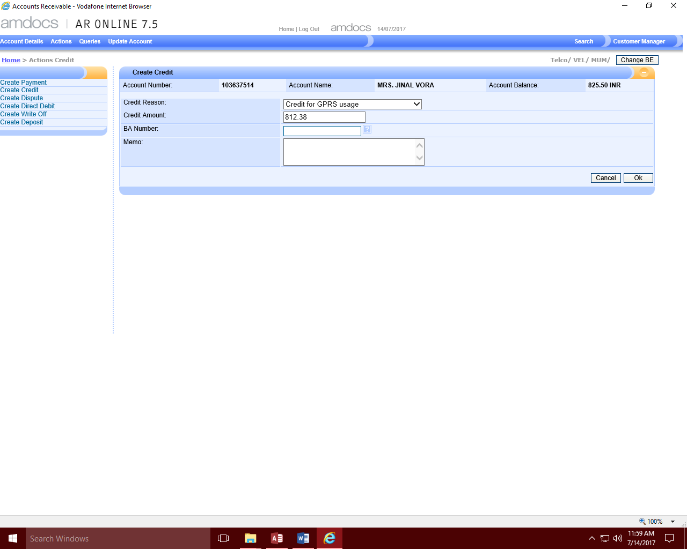

1. **Populating the Credit Reason and Amount**

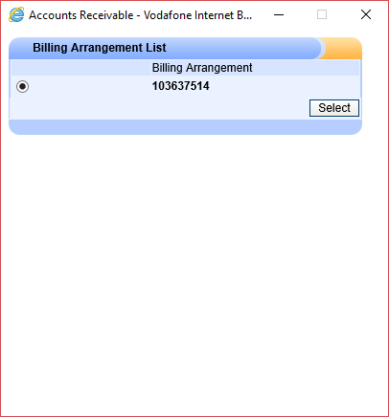

1. **Opening the BA number popup to select the BA Number**

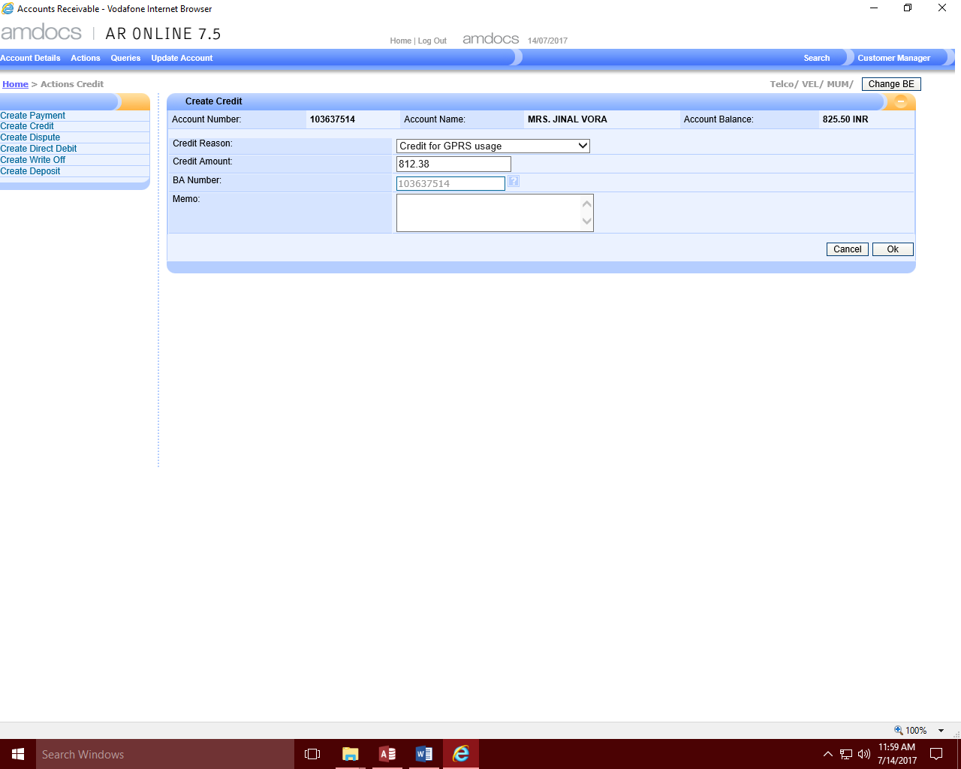

1. **Populating the BA Number from the popup**

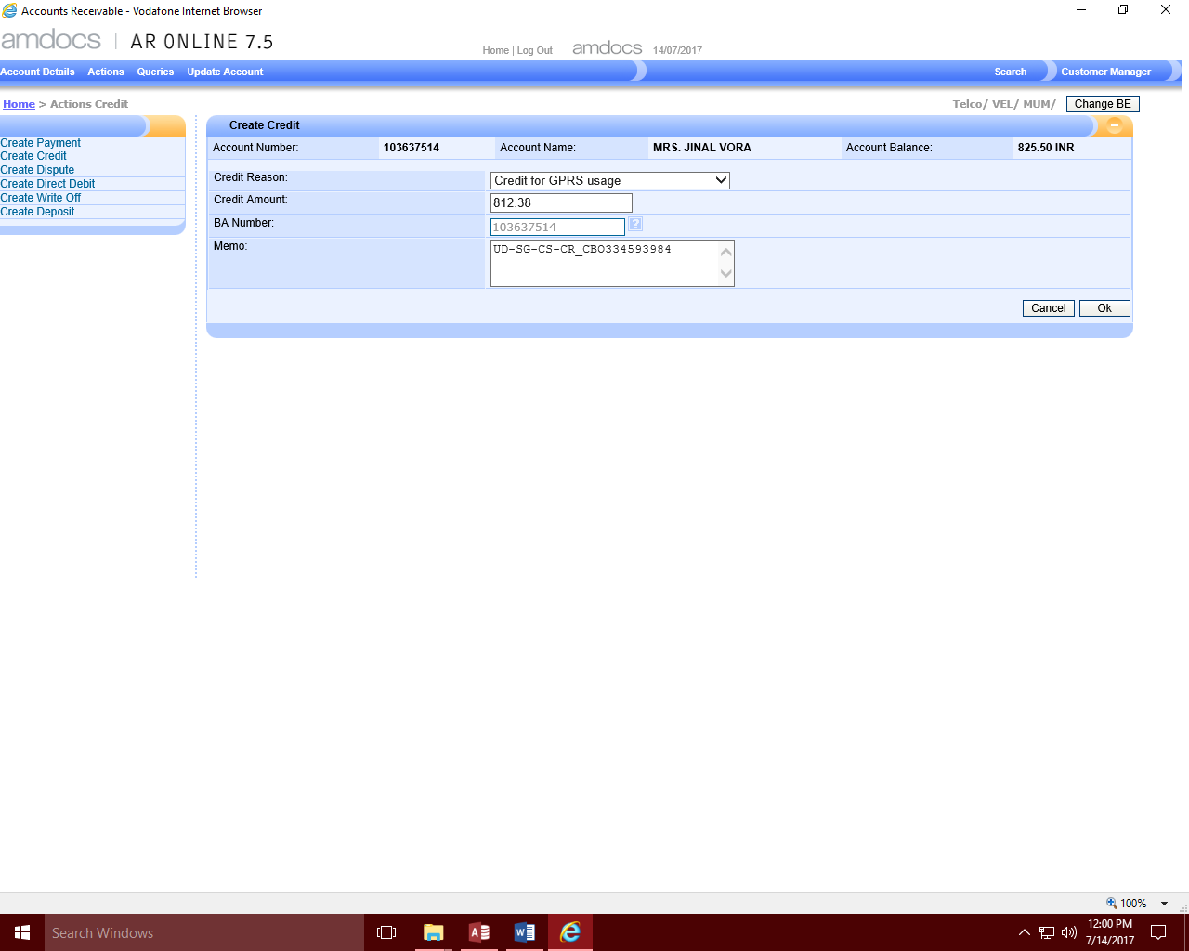

1. **Populating the Memo (Remarks) information for Posting to BCL**